EGRA COLLEGE LOGO  - FINAL.wmf

EGRA SARADA SHASHI BHUSAN COLLEGE

**ESTD. : 1968**

**(Reaccredited by NAAC with – ‘B’ Grade with a CGPA of 2.32)**

**Post – Egra : Dist – Purba Medinipur (West Bengal) : Pin – 721429.**

**Principal /Secretary : Dr. Dipak Kumar Tamili.**

**Website -** [www.egrassbcollege.ac.in](http://www.egrassbcollege.ac.in) **: E-mail –** [info@egrassbcollege.ac**.in**](mailto:info@egrassbcollege.ac.in%20)

**🖀 – 03220-244073 / 245557 : Fax – 03220245867.**

**========================================================================**

**Memo No. : 72 Date : 24.07.2021**

**NOTICE**

It is hereby notify that Dispute **B.A./B.Sc. (Hons. & Gen.) Marksheet** of **4th Sem. (CBCS)** **Exam**., 2020 will be distributed from the office (University Exam Section) on **26.07.2021** & **27.07.2021** from **11.00a.m. to 01.00p.m.** Respective Students are hereby advised to collect their **Marksheet with production of Money Receipt and Requisite Paper.**

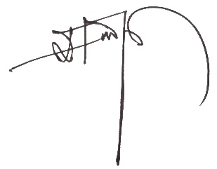

**Principal**

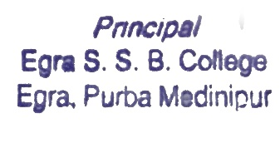 **Egra S.S.B. College**

**Copy to –**

1. **Head Clerk**
2. **Notice Book**
3. **Students’ Union**
4. **College Website**